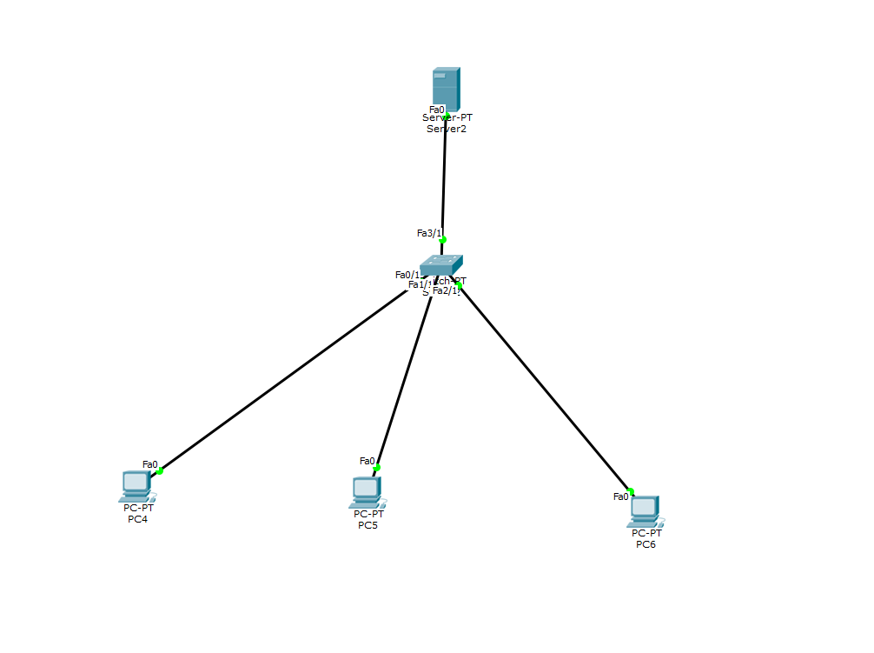

Dynamic Host Configuration Protocol (DHCP) is **a network protocol that is used to configure network devices to communicate on an IP network**. A DHCP client uses the DHCP protocol to acquire configuration information, such as an IP address, a default route, and one or more DNS server addresses from a DHCP server.

